6.4 Recommender System: Potential Interface Design Approaches
Table of contents

Summary - Work Package 6.4
The following document relates to the Advanced Analytics & AI Training Hub Work Package 6.4: Development of Personalised Recommender System. Within this package we reviewed four different approaches to building a tool for health researchers to search/navigate the courses compiled in the Coursework Database delivered in Work Package 6.2. Each of the approaches was reviewed in terms of their alignment with the current database tags as well as the estimated maintainability of each approach. Considering that the hosting and maintenance of the database and interface were unknown at the time of this project, we determined that maintainability would be an important consideration when evaluating deployment and product ownership options.
The four design approaches developed and evaluated were:
- Guided Needs Assessment Wizard - A step-by-step questionnaire that progressively narrows the course list. Researchers are walked through a structured decision tree.
- Faceted Filter & Search Dashboard
- AI-Powered Natural Language Query Interface
- Course Comparison & Shortlisting Tool
Prototypes for Approaches 1 and 2 were developed and user testing conducted (user testing is documented in Work Package 6.5). Developing a prototype for Approaches 3 and 4 was deemed outside of the scope and timeframe of this project.
The prototypes for Approaches 1 and 2 are included in the handover documents.

1. Design Approaches

1.1 Approach 1: Guided Needs Assessment Wizard

1.1.1 Description
A step-by-step questionnaire that progressively narrows the course list. Researchers are walked through a structured decision tree:
- What do you want to learn? R, Python, Bayesian Statistics, etc.
- What is your goal? Skill building vs. certification vs. academic credit
- What is your experience level? Beginner, intermediate, or advanced
- Do you need health research context? Essential, preferred, or not required
- What is your time commitment? Hours per week and total duration
- What is your budget? Free, subsidised, or paid
At each step, a live counter updates to show how many courses still match (“42 courses match so far”), ending with a ranked shortlist of recommendations. This suits researchers who do not know exactly what they are looking for and who benefit from guided exploration.

1.1.2 Implementation Readiness
Rating: ✅ Ready to build
The current database contains all fields required for this interface:
Wizard step | Database field
What do you want to learn | tool
Goal | Qualification, research_orientated, Format
Experience level | Level
Health context | health_research_context
Time commitment | weekly_time_commitment, Duration
Budget | Cost/Access

1.1.3 Maintainability
Rating: ⭐⭐⭐⭐ High
Factor | Assessment
Data updates | Adding new courses requires only appending rows to the source spreadsheet.
Logic changes | Decision-tree questions are configuration-driven; adding or reordering steps does not require code changes
Field changes | New filter dimensions (e.g. a new AI_governance field) can be added as new wizard steps with minimal code
Dependencies | Minimal: a static JSON file and a front-end framework; no database server required

1.2 Approach 2: Faceted Filter & Search Dashboard

1.2.1 Description
A side-panel filter interface (similar to academic databases such as PubMed or Scopus) giving researchers direct control over all search dimensions simultaneously. Filters include:
- Level (Beginner / Intermediate / Advanced)
- Format (Course / Specialisation / Professional Certificate / MOOC)
- Health Research Context (High / Medium / Low / Not covered)
- Primary programming language or tool
- Cost / Access model
- Research-oriented rating
Results display as cards showing platform, duration, cost, and health relevance at a glance. This approach suits power users who know what they want and prefer direct control.

1.2.2 Implementation Readiness
Rating: ✅ Ready to build
This is the most straightforward interface to build from the current data. All filter dimensions map directly to existing database columns.

1.2.3 Maintainability
Rating: ⭐⭐⭐⭐⭐ Very High
Factor | Assessment
Data updates | database updates flow directly to existing tool, no updates required
Logic changes | Filters are data-driven; adding a new filter is a configuration change
Scaling | Handles hundreds to low thousands of courses without performance concerns
Dependencies | Minimal; well-established libraries with long support horizons
This is the most maintainable of all four approaches.

1.3 Approach 3: AI-Powered Natural Language Query Interface

1.3.1 Description
A chat-style interface where researchers type queries in plain language, for example:
“I need a free intermediate Python course focused on health data with hands-on coding”
“What is the best course for learning Bayesian statistics for clinical research?”
“Show me advanced courses that cover AI ethics in healthcare”
An AI model (such as Claude via the Anthropic API) interprets the query, searches and ranks the database, and explains its recommendations in plain language. This approach makes use of the richer text fields in the database (Key Topics, health_research_context, notes, prerequisites, and Target Audience) which are not extensively utilised in the previous approaches.

1.3.2 Implementation Readiness
Rating: ⚠️ Ready with caveats
The current database contains sufficient information to power this interface. However, further preparation is recommended:
- Enrich free-text fields: The Key Topics and notes fields are the primary basis for semantic matching. These need to be improved to make them more meaningful.
- Define a retrieval strategy: Two approaches are viable:
  - Keyword + filter hybrid: Extract structured filters (level, cost, tool) from the query, then rank results by keyword match against Key Topics. Simpler and cheaper.
  - Embedding-based semantic search: Encode all course descriptions as vectors and retrieve by cosine similarity. Higher quality but requires an embedding model and vector store.

1.3.3 Maintainability
Rating: ⭐⭐⭐ Moderate
Factor | Assessment
Data updates | New courses must be re-embedded or re-indexed when added
AI model changes | Prompt logic may need adjustment if the underlying AI model changes
Cost | Ongoing API costs proportional to query volume; budget accordingly
Quality monitoring | Requires periodic review of query logs to identify poor responses
Dependencies | Higher dependency surface than static approaches; API availability matters
The AI layer introduces operational complexity. Further expertise is required to evaluate build requirements.

1.4 Approach 4: Course Comparison & Shortlisting Tool

1.4.1 Description
A structured comparison interface where researchers select up to five courses and view them side-by-side across dimensions that matter to health researchers:
Dimension | Example values
Health context relevance | High / Medium / Low / Not covered
Time commitment | 4 hrs/wk · 6 weeks
Cost | Free to audit / Paid
ML depth | Advanced: deep learning
Hands-on coding | Extensive
Ethics & AI safety | Covered / Limited / Not covered
Research-oriented | Yes: High
An optional scoring panel lets researchers weight dimensions by personal priority (e.g. health context 50%, cost 30%, level fit 20%) and receive a ranked composite score for each shortlisted course.

1.4.2 Implementation Readiness
Rating: ✅ Ready to build
All comparison dimensions map directly to existing database fields. This is the second most straightforward interface after the faceted filter (Approach 2).

1.4.3 Maintainability
Rating: ⭐⭐⭐⭐⭐ Very High
Factor | Assessment
Data updates | Same pipeline as Approach 2; no additional effort
Logic changes | requires platform updates
Scoring weights | User-controlled at runtime; no code changes needed
Dependencies | Minimal; same stack as Approach 2

1.5 Design Options: Summary & Recommendations

1.5.1 At-a-glance comparison
Approach | Readiness | Maintainability
1. Wizard | ✅ Ready | ⭐⭐⭐⭐ High
2. Faceted filter | ✅ Ready | ⭐⭐⭐⭐⭐ Very high
3. AI query | ⚠️ Caveats | ⭐⭐⭐ Moderate
4. Comparison tool | ✅ Ready | ⭐⭐⭐⭐⭐ Very high

2. Working Prototypes - Approach 1 & 2
The following screenshots demonstrate the screens of Approach 1: Guided Needs Assessment Wizard and Approach 2: Faceted Filter Dashboard. The prototypes have been developed as standalone HTML files and are included in the hand-over documents.

2.1 Approach 1: Guided Needs Assessment Wizard
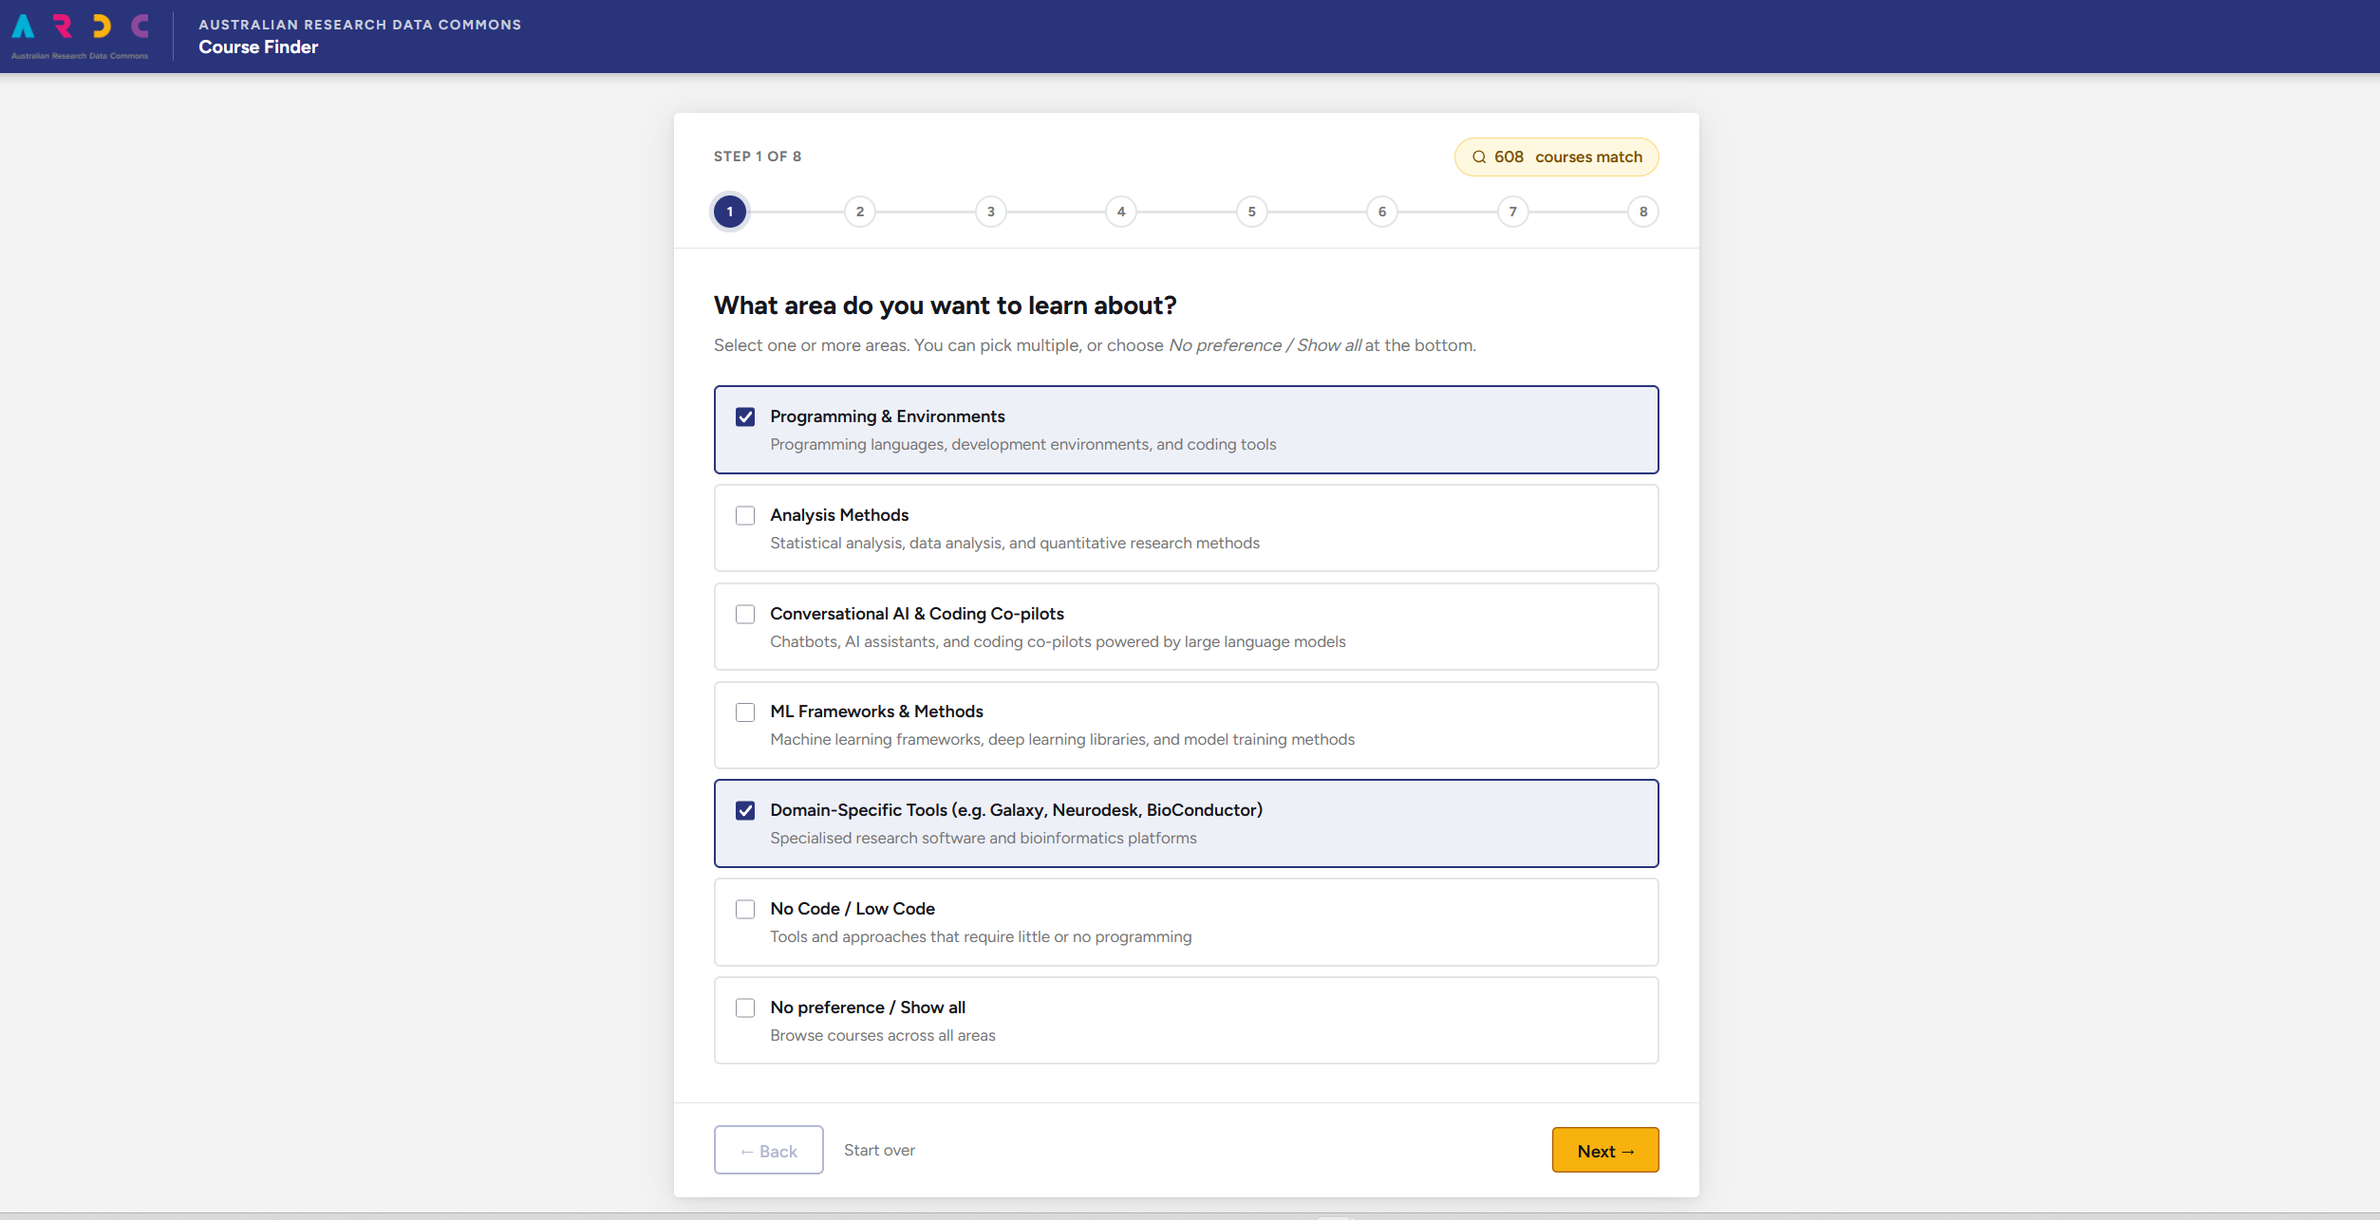
Approach 1 (Wizard V1): Landing Page
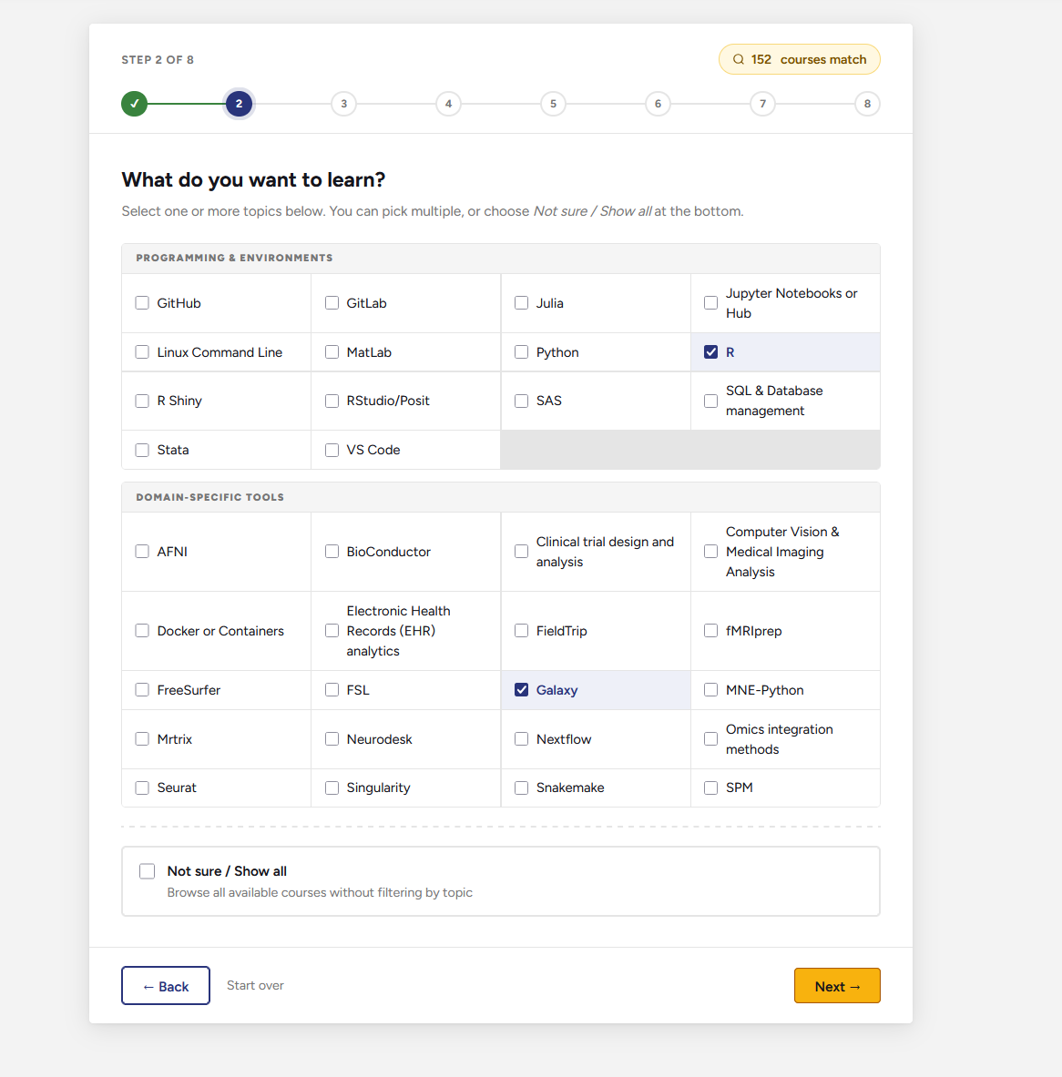  Approach 1 (Wizard V1): Page 2 | 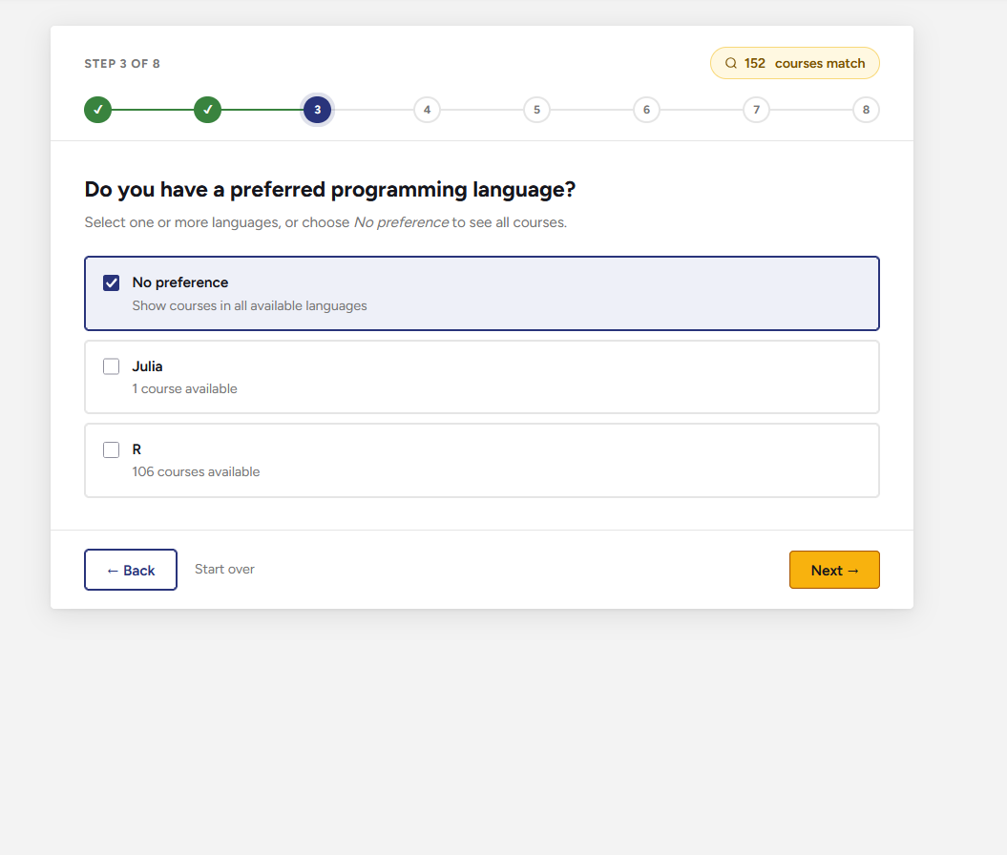  Approach 1 (Wizard V1): Page 3
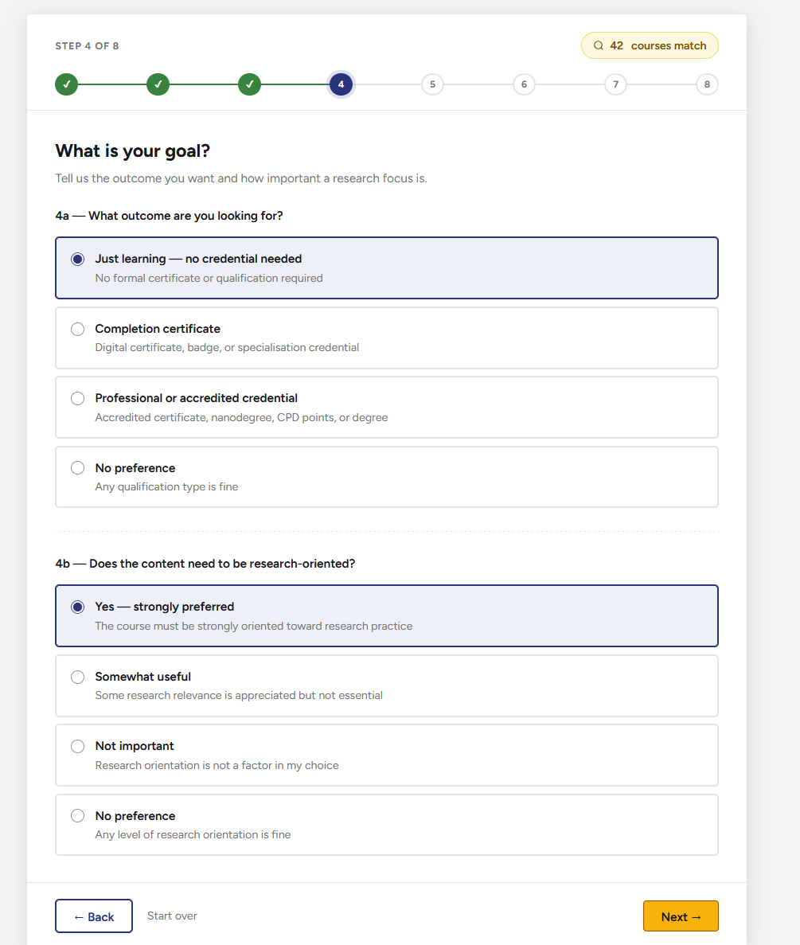  Approach 1 (Wizard V1): Page 4 | 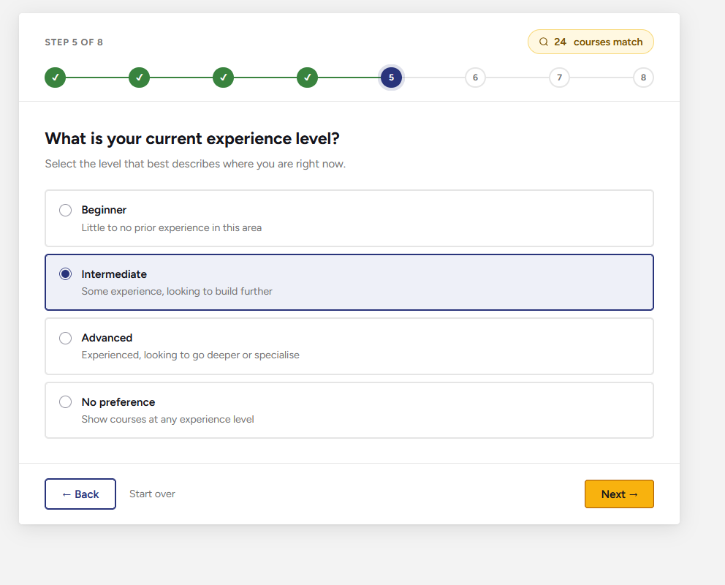  Approach 1 (Wizard V1): Page 5
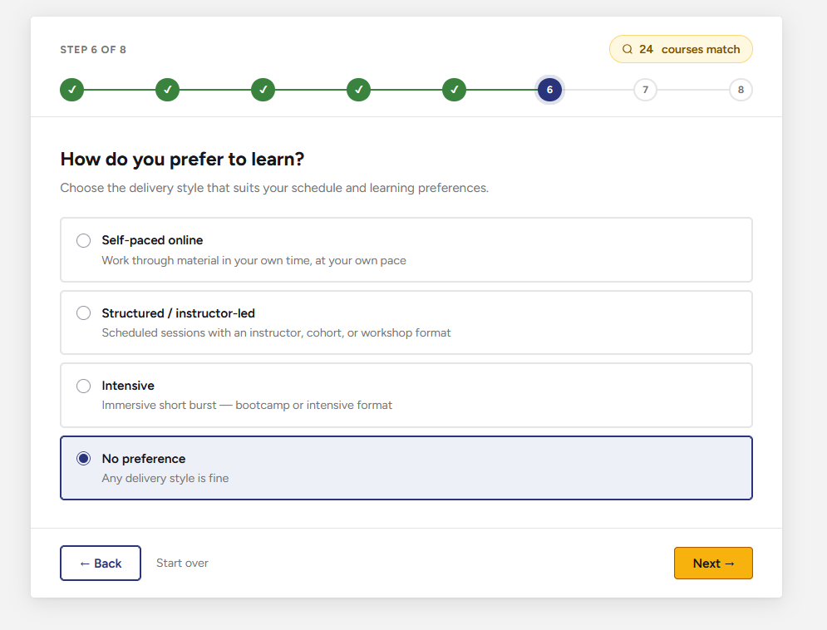  Approach 1 (Wizard V1): Page 6 | 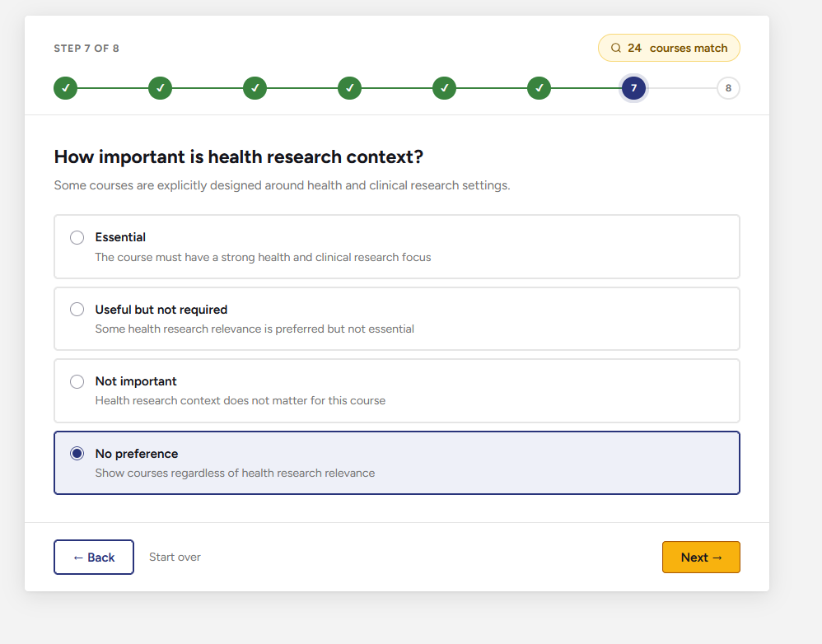  Approach 1 (Wizard V1): Page 7
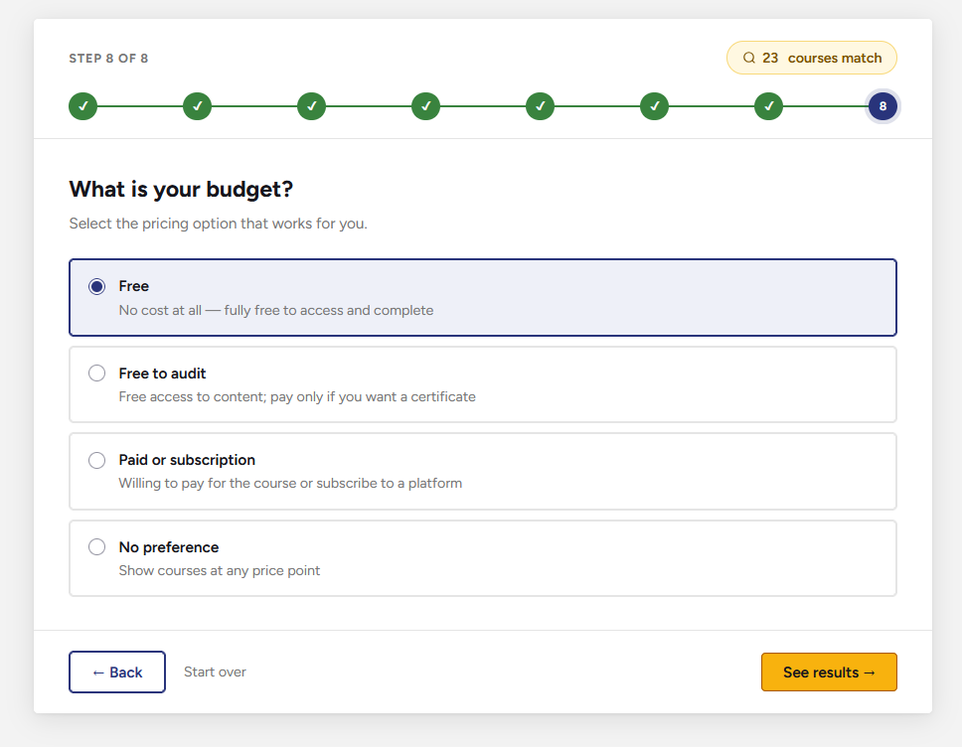  Approach 1 (Wizard V1): Page 8 | 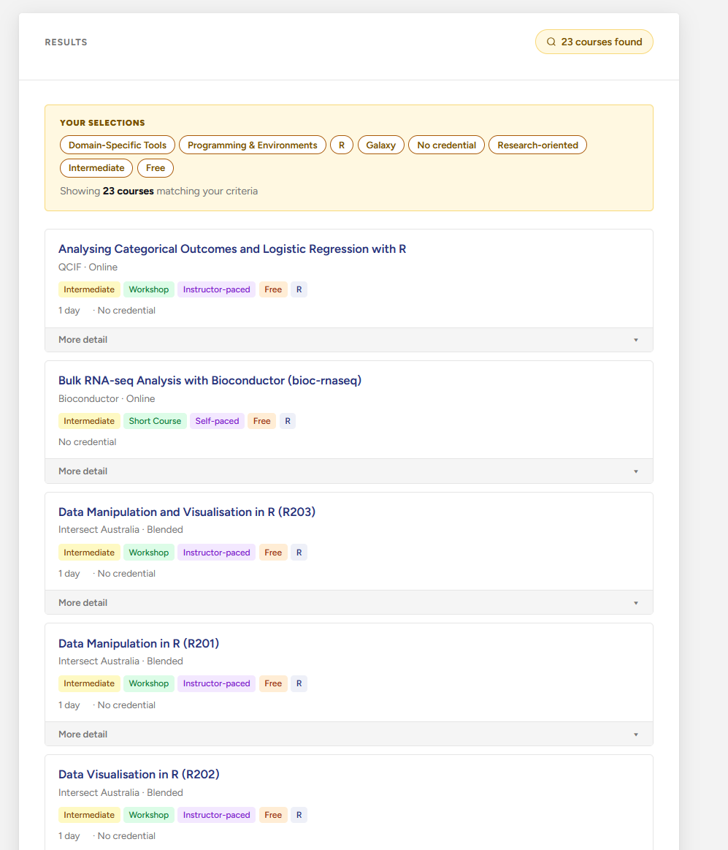  Approach 1 (Wizard V1): Results Page

2.2 Approach 2: Faceted Filter & Search Dashboard
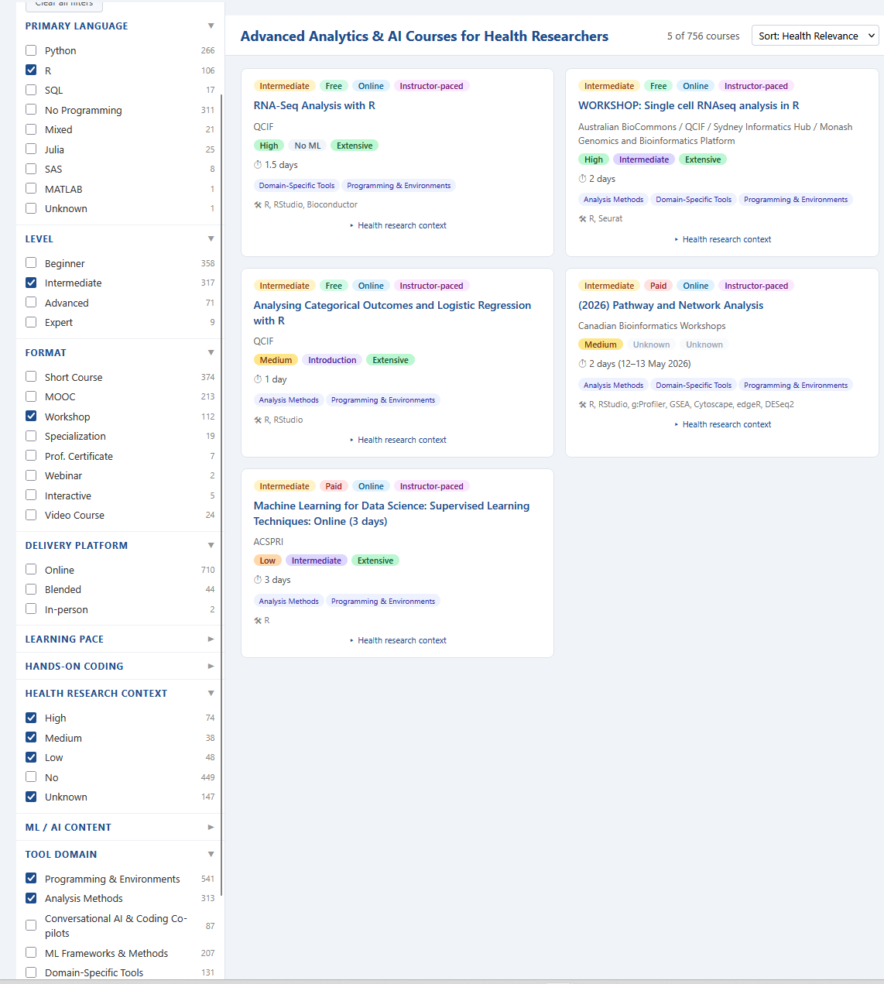
Approach 2 (Dashboard V1)

3. Summary & Conclusions
This work package developed four potential interface approaches for an interactive tool to help health researchers navigate the Advanced Analytics & AI Training Hub course database compiled in Work Package 6.2. The four approaches were assessed against two primary criteria: readiness to build given the current database structure, and long-term maintainability given that ongoing hosting and maintenance responsibilities had not been determined at the time of this project.
Three of the four approaches, the Guided Needs Assessment Wizard (Approach 1), the Faceted Filter and Search Dashboard (Approach 2), and the Course Comparison and Shortlisting Tool (Approach 4), were assessed as ready to build from the current database. The AI-Powered Natural Language Query Interface (Approach 3) was assessed as viable but requiring additional preparatory work, including enrichment of free-text fields and a defined retrieval strategy, before development could begin.
Prototypes for Approach 1 (wizard) and Approach 2 (dashboard) were developed to validate the functionality of the course database.

3.1 Recommendations
The following recommendations are made for those taking this work forward:
- Address database maintainability before or alongside any build. Ongoing currency of the coursework database will be critical to the utility of any interface. As outlined in Work Package 6.2, before investing in interface development, clear processes and responsibilities for updating, auditing, and retiring course records should be established. This is a data governance task and is independent of the choice of interface.
- Explore the requirements for Approach 3 (AI-Powered Natural Language Query Interface) for future consideration. This approach has the potential to provide a richer search experience by making use of the full text of course descriptions and metadata. It was outside the scope of this project, but the groundwork, particularly enriching the Key Topics and notes fields, could be laid in parallel with other data quality improvements.
- Embed ability for users to upload or recommend courses. Future versions of the tool should allow users to recommend training courses they have undertaken and/or provide feedback on courses that are already in the database.
The main ongoing effort and limitation of any approach is keeping course records current as courses are updated, retired, or added.

